

Global Grant Overview

**Sri Sathya Sai Sanjeevani Children’s Hospitals, India**

**Area of Focus:** Disease Prevention and Treatment

**Sponsor:** Rotary Club of Fort Wayne, Indiana, USA. District 6540.

**Background: It is estimated that of the 30 million live births each year in India, around 240,000 children (8 out of 1,000 live births) are born with congenital heart disease.** Congenital heart disease is the most common cause of infant mortality, accounting for 3-10% of infant deaths. Timely and affordable diagnosis, screening, and intervention is essential. Today, only 2-3% of infants in India who require congenital heart surgery actually undergo it, as either

the condition is undetected, or facilities are unavailable or unaffordable. **The result is that thousands of infants and children die needlessly every year.**

**Scope: The Sri Sathya Sai Sanjeevani Children’s Hospital system provides cardiac testing, procedures, and surgeries totally free of cost to families who would have no other way of accessing medical care for their child.** The hospital system accepts no government funding and is supported by philanthropic donations. A total of five hospitals are planned, with locations already open in Raipur, Palwal and Navi Mumbai.

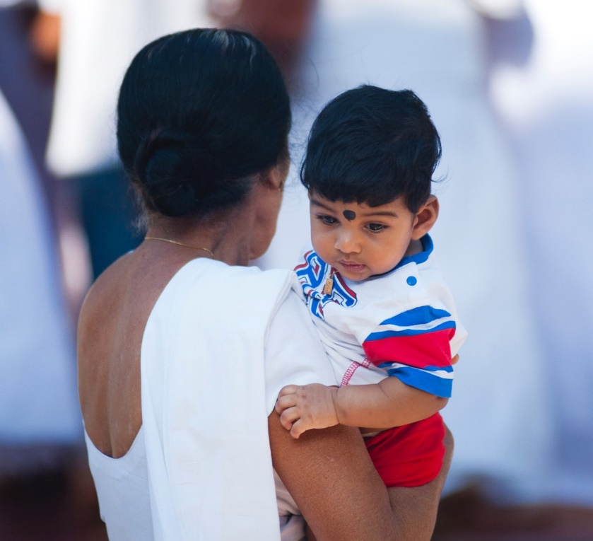

All of the hospitals operate on the same

model, **focusing on pediatric cardiology,**

**and are completely free to all families**.

This is significant as only one in four Indian families has health insurance. The remainder rely on the free/low-cost government hospitals. Often, the wait is so long for a cardiac procedure at a government hospital that the child will die while they are on the waiting list.

The Sri Sathya Sai Sanjeevani Children’s Hospitals will treat any low-income child; families have even traveled from Afghanistan, Africa, Pakistan and other countries to access care for their critically ill child.

**Impact:** In collaboration with Rotary Clubs in India, and through generous private donations, **there are 10 planned global grant projects to fund equipment and surgeries for the Sri Sathya Sai Sanjeevani Children’s Hospitals.**

**Three global grant projects have already been successfully funded:**

* In 2017, the Fort Wayne Rotary Club partnered with the Raipur Greater Rotary Club on a

$447,000 global grant for a pediatric catheterization lab in the Sri Sathya Sai Sanjeevani Children’s Hospital in Naya Raipur. This project included $120,000 in private donations from Fort Wayne Rotarians Drs. Praveen and Anuradha Kollipara and the Jyothi Corp.

This grant has been completed and closed and was very impactful, increasing cardiac procedures by 500 per year.

* In August 2018, a global grant project in collaboration with the Fort Wayne Rotary Club and the Rotary Club of Faridabad was approved by the trustees for $413,068 to provide an operative room and ICU for the Palwal hospital site. This project included $126,000 in private donations from Fort Wayne Rotarians Drs. Kollipara, the Jyothi Corp, and Sai Global Mission.
* In January 2019, a $394,677 collaboration between the Anthony Wayne Rotary Club and the Raipur Greater Rotary Club funded an operating theater and ICU in the Sri Sathya Sai Sanjeevani Children’s Hospital in Naya Raipur. This project includes $105,000 in private donations from Fort Wayne Rotarians Drs. Kollipara, the Jyothi Corp, and Sai Global Mission.

**Pending Projects:**

* **A project of $480,000 to fund a pediatric catheterization lab in the Sri Sathya Sai Sanjeevani Children’s Hospital in Navi Mumbai.** A commitment has been made of $100,000 in private donations from Fort Wayne Rotarians Drs. Kollipara, the Jyothi Corp, and Sai Global Mission. This project has been submitted and is pending with RI.
* **A project of approximately $450,000 to fund 350 lifesaving cardiac surgeries**, which average $1,200 US each. These surgeries will be performed at the Palwal hospital location. A commitment has been made of $100,000 in private donations from Fort Wayne Rotarians Drs. Kollipara, the Jyothi Corp, and Sai Global Mission.

**For more information about the critical services provided by the Sri Sathya Sai Sanjeevani Children’s Hospital:**

[https://www.youtube.com/watch?v=pFh3Abo23FU](http://www.youtube.com/watch?v=pFh3Abo23FU) [https://www.youtube.com/watch?v=2CxYCDenvq4](http://www.youtube.com/watch?v=2CxYCDenvq4)

**Contact: For more information, contact Dr. Holli Seabury**

**Cell: 260-760-4831 Email:** [**RotarianHolli@gmail.com**](mailto:RotarianHolli@gmail.com)

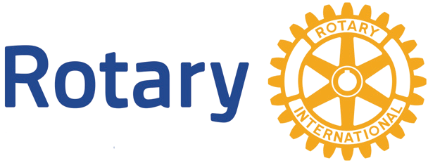Fort Wayne Club